Day 25 - 09th Aug 2025

Task01  Bridge Method  Structural Design Pattern:

package BridgeMethod;

public interface ExcalidrawAPI {

   void drawSquare(int s);

}

package BridgeMethod;

public class DrawingPicture implements ExcalidrawAPI {

   @Override

   public void drawSquare(int s) {

       System.*out*.println("Draw square in Drawing Picture using Excalidraw with side " + s);

   }

}

package BridgeMethod;

public class DrawingFrame implements ExcalidrawAPI {

   @Override

   public void drawSquare(int s) {

       System.*out*.println("Draw square in Drawing Frame using Excalidraw with side " + s);

   }

}

package BridgeMethod;

// Abstraction

abstract public class Shape {

   protected ExcalidrawAPI excalidrawAPI;

   protected Shape(ExcalidrawAPI excalidrawAPI) {

       this.excalidrawAPI = excalidrawAPI;

   }

   abstract void draw();

}

package BridgeMethod;

public class Square extends Shape {

   private int s;

   Square(int s, ExcalidrawAPI excalidrawAPI) {

       super(excalidrawAPI);

       this.s = s;

   }

   @Override

   void draw() {

       excalidrawAPI.drawSquare(s);

   }

}

package BridgeMethod;

public class Main {

   public static void main(String[] args) {

       System.*out*.println("Bridge Method Design Pattern - Structural DP!");

       // Draw square using DrawingFrame

       Shape square1 = new Square(5, new DrawingFrame());

       square1.draw();

       // Draw square using DrawingPicture

       Shape square2 = new Square(10, new DrawingPicture());

       square2.draw();

   }

}

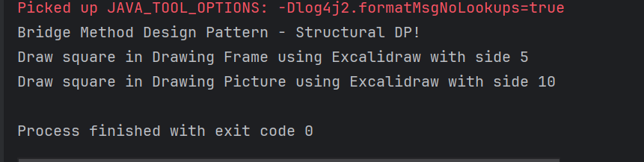

Task02  Composite Method Structural Design Pattern

package CompositeMethod;

// Base Component

public interface Company {

   void displayName();

}

package CompositeMethod;

import java.util.ArrayList;

import java.util.List;

// Composite component

public class CompanyHead implements Company {

   private int id;

   private String name;

   private List<Company> subDepartments;

   public CompanyHead(int id, String name) {

       this.id = id;

       this.name = name;

       this.subDepartments = new ArrayList<>();

   }

   @Override

   public void displayName() {

       System.*out*.println("Department: " + name);

       subDepartments.forEach(Company::displayName);

   }

   public void addDepartment(Company company) {

       subDepartments.add(company);

   }

   public void removeDepartment(Company company) {

       subDepartments.remove(company);

   }

}

package CompositeMethod;

public class HR implements Company {

   private int id;

   private String name;

   public HR(int id, String name) {

       this.id = id;

       this.name = name;

   }

   @Override

   public void displayName() {

       System.*out*.println("HR Dept: " + name);

   }

}

package CompositeMethod;

// Leaf component

public class Software implements Company {

   private int id;

   private String name;

   public Software(int id, String name) {

       this.id = id;

       this.name = name;

   }

   @Override

   public void displayName() {

       System.*out*.println("Software Dept: " + name);

   }

   // Getters

   public int getId() {

       return id;

   }

   public String getName() {

       return name;

   }

   // Setters

   public void setId(int id) {

       this.id = id;

   }

   public void setName(String name) {

       this.name = name;

   }

   // Optional: for debugging

   @Override

   public String toString() {

       return "Software{" +

               "id=" + id +

               ", name='" + name + '\'' +

               '}';

   }

}

package CompositeMethod;

public class Main {

   public static void main(String[] args) {

       System.*out*.println("Composite Method DP - Structural DP");

       // Create leaf departments

       Company softwareCompany = new Software(1, "Software Development");

       Company hrDepartment = new HR(2, "Human Resources");

       // Create composite head

       CompanyHead companyHead = new CompanyHead(3, "ABC Company");

       // Add leaves to composite

       companyHead.addDepartment(softwareCompany);

       companyHead.addDepartment(hrDepartment);

       // Display hierarchy

       companyHead.displayName();

   }

}

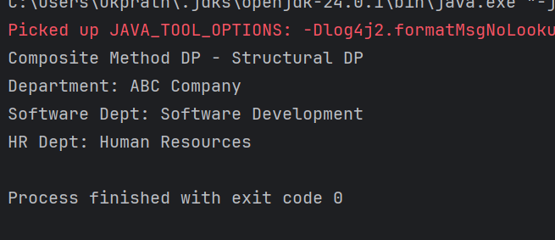

Task 03 Facade Method

package FacadeMethod;

public class BillingCounterService {

   public void payBill(String accountId, String billId, double amount) {

       System.*out*.println("paying for Mangoes "+ amount +"for billId "+ billId + "from account" +accountId);

   }

}

package FacadeMethod;

public class MallFacade {

   private StoreStaffService storeStaffService;

   private BillingCounterService billingCounterService;

   public MallFacade() {

       this.storeStaffService = new StoreStaffService();

       this.billingCounterService = new BillingCounterService();

   }

   public void getItems(String items) {

       storeStaffService.getItems(items);

   }

   public void payBill(String accountId, String billId, double amount){

       billingCounterService.payBill(accountId,billId, amount );

   }

}

package FacadeMethod;

public class StoreStaffService {

   public void getItems(String items) {

       System.*out*.println("selecting Mangoes");

   }

}

package FacadeMethod;

public class Main {

   public static void main(String[] args) {

       System.*out*.println("Facade Method DP - Structural Design Pattern");

       MallFacade mallFacade = new MallFacade();

       mallFacade.getItems("Fruits");

       // mallFacade.transferMoney("123", "7777", 500.0);

       mallFacade.payBill("123", "billno 44", 500.0);

   }

}

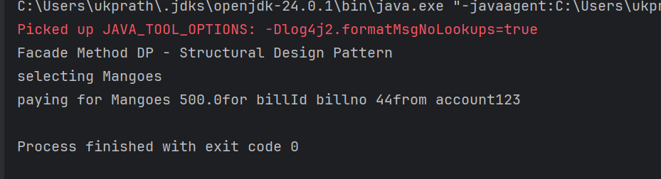

Task 04  Proxy design pattern

package ProxyMethod;

public class DataBase {

   void execute(String Query, String desig) {

       System.*out*.println("query execution is in process "+ Query);

   }

}

package ProxyMethod;

public interface DatabaseExecute {

   public abstract void executeQuery(String type);

}

package ProxyMethod;

import java.util.Objects;

public class ProxyDataBase implements DatabaseExecute{

   String desig;

   DataBase db;

   public ProxyDataBase(String desig){

       this.desig = desig;

       db = new DataBase();

   }

   @Override

   public void executeQuery(String Type){

       if(Type.equals("Delete") && (!Objects.*equals*(this.desig, "ADMIN"))) {

           System.*out*.println("you don't have permission to delete");

           return;

       }

       db.execute(Type, this.desig);

   }

}

package ProxyMethod;

public class Main {

   public static void main(String[] args) {

       System.*out*.println("Proxy Method Design Pattern - Structural design pattern");

       DatabaseExecute emp1 = new ProxyDataBase("ADMIN");

       emp1.executeQuery("Delete");

       emp1.executeQuery("Write");

       emp1.executeQuery("Read");

       DatabaseExecute emp2 = new ProxyDataBase("HR");

       emp2.executeQuery("Delete");

       emp2.executeQuery("Write");

       emp2.executeQuery("Read");

       DatabaseExecute emp3 = new ProxyDataBase("EMPLOYEE");

       emp3.executeQuery("Delete");

       emp3.executeQuery("Write");

       emp3.executeQuery("Read");

   }

}

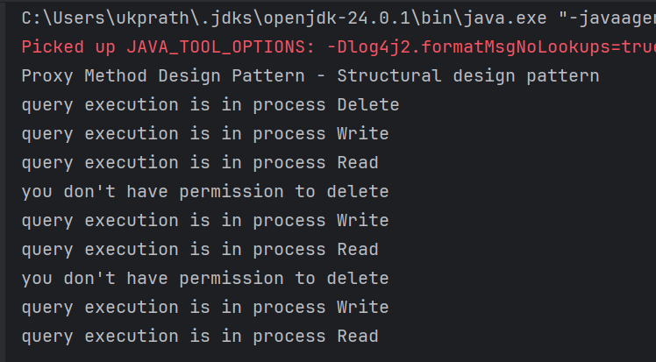

Task 05 Command Method Design Pattern

package BehavioralDP.CommandPattern;

public interface Command {

   void doIt(); // executing a command

}

package BehavioralDP.CommandPattern;

public class DontDoTask implements Command {

   private Task task;

   public DontDoTask(Task task) { // ✅ Proper constructor

       this.task = task;

   }

   @Override

   public void doIt() {

       this.task.dontTask();

   }

}

package BehavioralDP.CommandPattern;

public class DoTask implements Command {

   private Task task;

   public DoTask(Task task) { // ✅ Proper constructor

       this.task = task;

   }

   @Override

   public void doIt() {

       this.task.doTask();

   }

}

package BehavioralDP.CommandPattern;

public class Mom {

   private Command command;

   public void setCommand(Command command) {

       this.command = command;

   }

   public void executeCommand() {

       this.command.doIt();

   }

}

package BehavioralDP.CommandPattern;

public class Task {

   public void doTask() {

       System.*out*.println("do your home tasks");

   }

   public void dontTask() {

       System.*out*.println("don't do your home tasks");

   }

}

package BehavioralDP.CommandPattern;

public class Main {

   public static void main(String[] args) {

       System.*out*.println("Command Pattern - Behavioural DP");

       Task task = new Task();

       Mom remote = new Mom();

       Command onCommand = new DoTask(task);

       Command offCommand = new DontDoTask(task);

       remote.setCommand(onCommand);

       remote.executeCommand();   // "do your home tasks"

       remote.setCommand(offCommand);

       remote.executeCommand();   // "don't do your home tasks"

   }

}

